



Revised 10/2025




*TO BE COMPLETED BY THE VICTIM ASSISTANCE COORDINATOR*
If you have questions or need assistance completing this form, please contact:
Victim Assistance Coordinator:

Agency:
Mailing Address:

City: State: ZIP:
Work Phone: Fax:
Email:
Defendant(s) Name (Last, First MI) | Case/Cause No. | TDCJ/SID No.
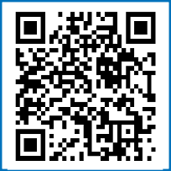
If you are under the age of 18, please complete this Victim Impact Statement with a trusted adult. The following instructions are to help you and your parent/guardian to complete the form:

DO NOT INCLUDE DETAILS ABOUT THE CRIME IN YOUR STATEMENT, ONLY HOW THE CRIME HAS IMPACTED YOU.
- This document is meant to be a way for you to express feelings you may have about what happened and how it impacts your life. This is YOUR statement! We hope completing this Victim Impact Statement will empower you to continue to use your voice throughout this process.
- The prosecutor, judge, probation, and parole board will consider your statement before making any major decisions regarding the case.
- If filling out this form feels like too much, you can draw or write in space provided on the statement instead.
- If you become uncomfortable in any way while filling out the Victim Impact Statement, you can ask for your parent/legal guardian’s help or speak with the Victim Assistance Coordinator listed above.

Victims of crime in Texas have rights mandated to them by law. Please scan this QR code to view the Crime Victims’ Rights video that explains the legal definition of a crime victim and the crime victim’s rights found in the Texas Code of Criminal Procedure Art. 56A.001(3) and Art. 56A.051.

 THIS PAGE IS FOR YOUR RECORDS 

C ONFIDENTIAL VIC TIM C ON TA C T
INFORM ATION



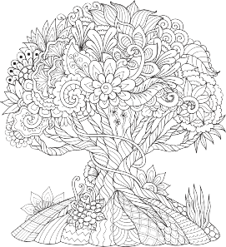
*TO BE COMPLETED BY THE VICTIM ASSISTANCE COORDINATOR*

Defendant(s) Name (Last First MI) | Case/Cause No. | TDCJ/SID No.

*TO BE COMPLETED BY THE VICTIM OR PARENT/LEGAL GUARDIAN*

CONFIDENTIAL VICTIM INFORMATION (Please use dark ink and print clearly)
*IF A PSEUDONYM WAS USED FOR THE CASE, PLEASE USE THAT RATHER THAN YOUR NAME.
What is your name/pseudonym? (Last Name, First Name MI):
Male |  | Female
If you attend school, what grade are you in? |  |  |  |  |  |  |  |  | Date of Birth:
Email Address: |  |  |  |  |  |  |  |  |  | Relationship to Victim:
Check if mailing address is the same as the parent/legal guardian listed below.
Mailing Address (if it is not the same as the address listed below):
City: |  |  |  |  |  | State: |  |  |  |  | ZIP:
Please provide the contact information of someone who will know how to reach you.
Parent/Legal Guardian Name:
Mailing Address:
City: |  |  |  |  |  | State: | ZIP:
Home/Cell Phone: |  |  |  |  |  |  | Work Phone:
Email Address: |  |  |  |  |  |  |  | Relationship to Victim:



Cause No:

HOW ARE YOU FEELING RIGHT NOW? (CIRCLE AS MANY AS YOU LIKE)

HAPPY
OVERWHELMED DISBELIEF CONFUSED SAD
FRUSTRATED

EMBARRASSED
SICK TO YOUR STOMACH
ANGRY DISAPPOINTED WORRIED DRAW HOW
YOU FEEL

For this part, please think about what happened to you and how it makes you feel. It may be hard but it is OK to have feelings about what happened and to talk about them. You are important and what you say matters.
If filling out the Victim Impact Statement becomes too difficult, you can stop and that is OK.

HOW HAS THIS CRIME MADE YOU FEEL? (CIRCLE AS MANY AS YOU LIKE)

HAPPY
OVERWHELMED DISBELIEF CONFUSED SAD
FRUSTRATED

EMBARRASSED
SICK TO YOUR STOMACH
ANGRY DISAPPOINTED WORRIED DRAW HOW
YOU FEEL












If you have physical injuries from the crime, please describe them here:

Cause No:
Did you start seeing a therapist/counselor after the crime? YES NO

What has changed in your life since the crime? (School, work, family relationships, friends? Anything else?)

This part of the Victim Impact Statement is for sharing your thoughts and feelings in your own words. You can use the lines below to write a poem, tell a story, or explain how you are feeling about what has happened to you. Remember, you do not need to include details about the crime, only how the crime has impacted you.
If you do not want to write anything you can draw something on the following page instead.

PLEASE RETURN TO YOUR VICTIM ASSISTANCE COORDINATOR

Cause No:

You can use this page to draw a picture and write a description.
If you do not want to draw anything, that is OK too.

Date completed

Victim/Pseudonym Signature Parent/Guardian/Counselor Signature

Information submitted by: Victim Other Relationship:

Cause No: ADDITIONAL PAGE
REMEMBER, YOU DO NOT NEED TO INCLUDE DETAILS ABOUT THE CRIME, ONLY HOW THE CRIME HAS IMPACTED YOU.

RESOURCES

The following list of resources is intended to provide victims and their parent/guardian with additional support while moving through the criminal justice process.

General Resources for Parents/Legal Guardians and Minor Victims
The Texas Victim Resource Directory is a compilation of nonprofit and governmental agencies that provide services to crime victims free of charge in Texas.
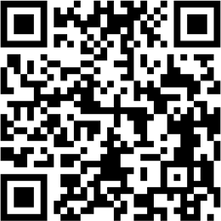

The Office for Victims of Crime’s “Child Victims and Witnesses Support Materials: A Guide for Parents and Caregivers” includes materials for young children ages 2 to 6 years old, school-age children ages 7 to 12 years old, and youth ages 13 to 18 years old.
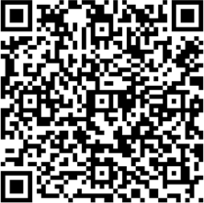

The American Academy of Child & Adolescent Psychiatry’s “Facts For Families Guide” provides up-to-date information on issues that affect children, teenagers, and their families.
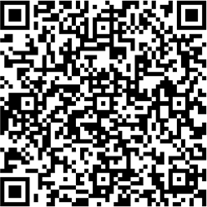

The National Center for Victims of Crime’s “Teen Tools” series offers bulletins explaining how to recognize a crime, what emotions to expect, and how to receive or give help. While language is aimed at teens, there is an Information for Parents of Teens page as well.

Family Violence/Dating Violence Resources
Promising Future’s “Everyday Magic: 7 Ways Parents and Caregivers Can Help Children Affected by Family Violence” offers a guide for parents, extended family members, and other adults who have experienced violence in a relationship.
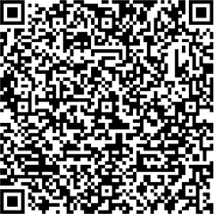

Love Is Respect provides resources to teens and young adults experiencing dating violence. Their “Support Your Child” page provides resources to parents/guardians who suspect that their child is in an abusive dating relationship and how parents/ guardians can be supportive even when they are scared for their child’s safety.
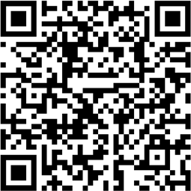

Resources for Child Sexual Abuse
The National Child Traumatic Stress Network’s “Caring for Kids: What Parents Need to Know About Sexual Abuse” fact sheet series provides parents and caregivers with tools to help them support children who have been victims of sexual abuse.
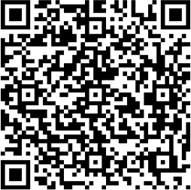

Talk About Abuse to Liberate Kids (TAALK) offers an online weekly support group for parents whose children have been sexually abused.

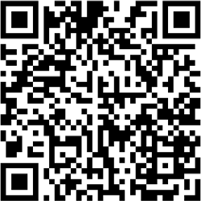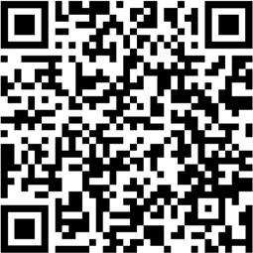

RESOURCES

The following list of resources is intended to provide victims and their parent/guardian with additional support while moving through the criminal justice process.

General Resources for Those With Differing Abilities

The Texas Workforce Commission’s Vocational Rehabilitation Program can assist adult victims of family violence who have a disability to help get ready for, find, or keep a job. Young student victims of family violence with disabilities can use this resource to prepare for life after school.
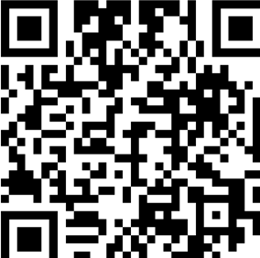

The Texas Health and Human Services’ Early Childhood Intervention Program services children from birth up to 36 months of age with a developmental delay or disability.
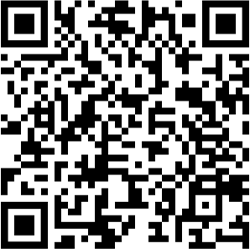

The Office of Deaf and Hard of Hearing Services is the center for awareness and education on deaf and hard of hearing issues and services in Texas. This office helps connect people to resources and services.
The Pennsylvania Coalition to Advance Respect created “SAFE: A Personal Safety Training Guide for Adults with Disabilities and Care Providers” to educate adults with disabilities about abuse.


The Americans with Disabilities Act website operated by the U.S. Department of Justice provides free publications by mail and fax through its ADA Information Line; publications may also be viewed or downloaded at ADA.gov.


The Texas Health and Human Services’ Children’s Autism Program provides focused Applied Behavioral Analysis (ABA) services through local community agencies and organizations to help improve the quality of life for those on the autism spectrum and their families.

